Simple Sentence

✅ Definition:
# Source: Chatgpt (GPT-4-turbo) at [7/29/2025]
A simple sentence is a sentence that contains one independent clause and no dependent clauses.
It expresses one complete thought.
It may have a subject, verb, and objects/modifiers, but only one main clause.

🧱 Basic Structure:
# Source: Chatgpt (GPT-4-turbo) at [7/29/2025]
[Subject] + [Predicate]
It may also include:
- Compound subjects (e.g., Tom and Jerry)
- Compound verbs (e.g., runs and jumps)
- Modifiers (adjectives, adverbs, prepositional phrases)

✏️ Examples of Simple Sentences:
# Source: Chatgpt (GPT-4-turbo) at [7/29/2025]
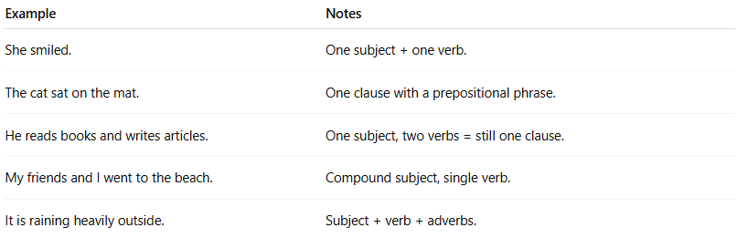
Example | Notes
She smiled. | One subject + one verb.
The cat sat on the mat. | One clause with a prepositional phrase.
He reads books and writes articles. | One subject, two verbs = still one clause.
My friends and I went to the beach. | Compound subject, single verb.
It is raining heavily outside. | Subject + verb + adverbs.

❗ Important Notes:
# Source: Chatgpt (GPT-4-turbo) at [7/29/2025]
- A simple sentence is not always short.
Long sentences can still be simple if there's only one independent clause.
✅ Despite the heavy traffic, she arrived at the meeting on time.
→ One clause = simple sentence.
- No subordinating conjunctions (unless part of a phrase within the clause, not forming a dependent clause).

🧠 Test Yourself – Simple or Not?
# Source: Chatgpt (GPT-4-turbo) at [7/29/2025]
- The dog barked loudly. ✅
- I washed the dishes, and she swept the floor. ❌ (Compound)
- After I finished dinner, I watched TV. ❌ (Complex)
- The stars twinkled. ✅
- John and Sarah traveled to Paris. ✅

